GASTRIC DISEASE DETERMINATION USING ADVANCED DEEP LEARNING

Dr.K.Sangeetha  
*ComputerScience and Engineering*  
  
*Panimalar Engineering College* Chennai, India  
sangeethakalyaniraman@gmail.com

Divya Dharshini.R  
 *ComputerScience and Engineering*  
 *Panimalar Engineering College* Chennai, India  
 dharshini17082000@gmail.com

H.Dhivyadharshini  
 *ComputerScience and Engineering*  
*Panimalar Engineering College*Chennai, India

dhivyadharshinihitler22@gmail.com

Keerthana.S   
*ComputerScience and Engineering*  
 *Panimalar Engineering College*Chennai, India  
 keerthu0411@gmail.com

*Abstract*—Gastric cancer is perhaps the most widely recognized harmful cancers with unfortunate prognostic outcome. Endoscopic assessment is primarily used for early recognition, while obsessive affirmation and computed tomography scanning are proposed for additional treatment. Gastric cancer growth stays as one of the dangerous cancers with unfortunate forecast. The overall lack of pathologists offers a one kind of chance for the utilization of artificial intelligence assistance system to help frameworks to ease the responsibility and increment diagnostic accuracy. Most gastric cancer shows hereditary instability, either microsatellite precariousness or chromosomal precariousness, which is viewed as an early stage in gastric carcinogenesis. Contemporary classification of gastric cancer in view of histological highlights, genotypes and subatomic phenotypes assists better with understanding the qualities of each subtype, and work on early analysis, anticipation and treatment. This task fosters a strategy utilizing deep learning algorithms to anticipate the health issues like ulcer, heartburn, indigestion and nausea which includes various tests to show up the end. Progressed algorithm, MIFNET is utilized to precisely analyze the presence of illness efficiently. MIFNET is a aggregation of three distinct algorithm, called as multi task net, fusion net and global net, the aggregation of which gives precise expectation of gastric cancer without any further diagnosis. A web application utilizes React.js will be produced for getting the contribution from the client and then showing the anticipated outcome. Hence, this proposed system helps in powerful determination of gastric cancer with greater accuracy than the existing system. Subsequently, this proposed work helps in successful analysis of Gastric Cancer in various parts of the stomach with greater accuracy than the existing system.

Keywords— MIFNET, CT, GC

# Introduction

Gastric cancer, additionally called stomach cancer, starts when cells in the stomach begin to grow out of control. Gastric cancer is an infection wherein harmful (malignant growth) cells structure in the inner lining of the stomach. It can develop at any part of the stomach. Stomach disease side effects can differ. Simultaneously, these side effects may not show up for a long time since stomach diseases can develop gradually. Before a real cancer creates, pre-malignant growth changes frequently in the inner lining of the stomach. These early changes seldom cause side effects, so they frequently remain undetected. The malignant growth in different area of stomach can influence treatment taken for stomach problems. For instance, cancer that develop in the stomach intersection are normally organized and regarded equivalent to malignant growths of the esophagus.

In spite of the reduction in frequency and mortality throughout the course of recent a very long time in certain nations, gastric disease is as yet the 6th most normal danger and stays the fourth leading reason for malignant growth related demise across the globe. Giving exact, fast evaluating for gastric cancer is significant. In the event that a patient is anticipated as being at high gamble, (s)he can look to attempt preventive measures ahead of time. Gastric malignant growth was for the most part analyzed at cutting edge stages due to their idle and vague side effects, which prompted unfortunate forecast.

In recent years, a few uses of artificial intelligence have arisen in the gastric malignant growth field in light of its effective computational power and learning limits, for example, picture based conclusion and forecast expectation. Simulated intelligence helped determination incorporates pathology, endoscopy, and automated tomography, while analysts in the visualization circle specialize in repeat, metastasis, and survival prediction. A complete screening strategy utilizing AI and many elements, gathered day to day as information in clinics, could work on the exactness of screening to group patients at high or low risk of creating gastric disease.

# LITERATURE SURVEY

Gastroscopy is a generally embraced technique for finding gastric sores. In any case, the viability of conventional gastric cancer screening techniques relies upon the clinical abilities of the gastroscopy professionals. An absence of data and experience might prompt improper analysis and abuse, particularly in locally developed clinics. As of late, there has been a huge development in investigations on information driven computer-aided analysis techniques. An original insightful dynamic technique for gastric cancer diagnosis, a multi-modal semantic fusion based information driven dynamic framework[10]. Gastric cancer diagnosis takes advantage of a hybrid consideration mechanism to separate text-based semantics from multi-modal gastroscopy reports and performs semantic combination to coordinate the semantics of printed gastroscopy reports and pictures, bringing about superior interpretability of gastroscopy discoveries. Gastric cancer diagnosis utilizes a genuine gastroscopy report dataset, and trial results which shows the contrasted techniques. Gastric cancer diagnosis accomplishes better responsiveness and exactness in stomach cancer screening. Stomach cancer diagnosis accomplishes better responsiveness and precision in stomach cancer diagnosis.

One of the most frequently mutated genes of all cancer is guardian of the genome called TPI53[7]. In spite of the significant natural role of TPI53, the clinical importance of TPI53 changes, in gastric cancer, remains to a great extent obscure. Consequently, the place of the TP53 transformation could influence clinical results in stomach cancer. The methodical assessment of transformations in TPI53, from the cancer genome atlas gastric cancer dataset in UCSCI xena storehouse. In particular, the analysis on five parts of each mutational position: (i) the entire quality body; (ii) known problem areas; (iii) the DNA-restricting space; (iv) the optional construction of the space; and (v) individual change positions.

Another structure of processing propelled multi focal cancer location methodology has been proposed[9]. Under the rubric of multifocal cancer location methodology, the growth of cancer cells focuses to be distinguished are viewed as elucidation of the goal work. The cycle that the nano-robots recognize cancers by analyzing in the high-risk tissue locale can be viewed as the interaction which was seen by specialists as an elucidation of a goal work in the boundary space for certain requirements. For multimodal advancement intending to find different ideal solutions in a solitary reenactment way, the niche innovation has been generally utilized. It tends to be utilized to recognize the world-wide optima of numerous mound functions in a running, actually keep the variety of the populace, and rashly stay away from the genetic algorithm. Gaining from the streamlining method of niche genetic algorithm, the niche genetic algorithm-enlivened multi focal cancer location methodology to find the cancer spots efficiently while considering practical in vivo proliferation and controlling of nano-robots, which is not quite the same as the utilization of the standard niche genetic algorithm is proposed. To work on the exhibition of the multi focal cancer location methodology, the hybrid administrator of the first niche genetic algorithm from crossing populace to going between two populaces. At last, an exhaustive mathematical guides to show the viability of the niche genetic algorithm-roused multi focal cancer location methodology when the organic goal work is related with the blood flow profile brought about by growth prompted angiogenesis. It very well may be utilized to recognize the worldwide optima of different mound algorithms in a running, actually and keep the variety of the populace. More examination expected for continuous execution.

In this system, the vascular endothelial growth factor sensor for analysis of cancer from human blood. This outcomes in a capacitance change between the micro-needles and afterward peruses out by a three-step capacitance-to-advanced converter[8]. The proposed three-step capacitance-to-advanced converter comprises of a coarse-6b slant analog to digital converter and a fine 15c ceaseless time delta-sigma modulator. The power utilization is 250 µW. The sensor framework effectively identifies the vascular endothelial growth factor sensor in both phosphate-cushioned saline and human blood serum can cause vascular illness in the retina of the eye.

An inventive deep convolutional neural network joined with surface guide for identifying malignant locales and denoting the ROI in a solitary model consequently[3]. Deep convolutional neural network model contains three cooperative branches, in particular an upper branch to perform oral cancer recognition, and a lower branch to perform semantic division and ROI checking. With the upper branch the organization model concentrates the harmful districts, and the lower branch makes the carcinogenic locales more accurately. To make the highlights in the harmful more standard, the organization model concentrates the surface pictures from the information picture. At long last, the standard deviation values are utilized to develop a surface guide, which is divided into various fixes and utilized as the info information to the deep convolutional network model.

Non-warm plasmas are known for their capacity to instigate warm free cyto-toxic impacts on cancer cells. Nonetheless, as the assortment of plasmas gadgets builds, examination of their cyto-toxic impact turns out to be progressively fundamental. However, the treatment time expected to arrive at a similar efficacy is in excess of quite a bit longer utilizing the Ω and the γ modes than utilizing the fly mode [5]. In all cases, utilizing the proper treatment time, cells display an impeded multiplication and, in the end, begin to give indications of cell passing.

Because of mechanical advances the quality and accessibility of organic information has expanded emphatically somewhat recently. Dissecting protein communication organizations in an incorporated way, along with sub-cellular compartment information, gives such natural setting, serves to fill in the holes between a solitary kind of natural information and qualities causing illnesses and can recognize novel qualities connected with sickness.. For the top qualities scored by BGCCD approach, utilizing the writing recovering technique to test the connections of them with the bosom malignant growth. The outcomes show that BGCCD find some original bosom cancer competitor qualities which are important references for the biomedical researchers. A strategy for coordinating sub-cellular confinement information with PPIINs that recognizes cancer applicant qualities in protein buildings. The burden of a solitary kind of organic data, like the misleading positive rate in the protein communications [13].

Auxiliary utilization of clinical enormous information is turning out to be progressively well known in medical care administrations and clinical exploration in medical industry. Cancer recurrence is a common phenomenon of cancer patients after therapy [10]. Concentrating on the time and impacting variables of cancer repeat can give successful clinical mediation implies, which is the good news of malignant growth patients.

Right now, the affirmation of analysis of bosom malignant growth is made by infinitesimal assessment of a super flimsy cut of a needle biopsy example. This cut is routinely formalin-fixed and stained with hematoxylin-eosin and outwardly analyzed under a light magnifying lens [11]. This cycle is work escalated and requires exceptionally gifted specialists. Higher ingestion contrast factor and volume part contrast implies higher centralization of lipids in ordinary tissues when contrasted with destructive tissues, a reason for outline. These fundamental outcomes support the imagined idea for painless and non-cancer-causing NIIR-based bosom cancer symptomatic stage, which will be tried utilizing a bigger number of tests. Higher assimilation contrast factor and volume division contrast (N/Ci) connotes higher convergence of lipids in typical tissues when contrasted with malignant tissues. The inconvenience of NIR is reliance on an enormous reference set.

A picture sensor consolidating angle selective gratings for goal upgrade in contact imaging applications. The shortfall of huge optical components empowers outrageous scaling down, permitting control inside a little, morphologically intricate, growth depression [4]. Exhibit imaging and discovery of foci containing under 500 cancer cells marked with fluorescent biomarkers in 200ms with signal-to-clamor proportions more 3 noteworthy than 30dB. Scaled down optical components are hard to manufacture and they frequently experience the ill effects of expanded abnormalities.

Automated bosom ultrasound, is an innovative and promising method of screening for breast examination. Regardless, looking into Automated bosom ultrasound pictures is especially time-concentrated and mistakes by oversight could happen. For this review, we offer an imaginative 3D convolutional network, which is utilized for automated bosom ultrasound for computerized malignant growth recognition, to speed up inspecting and in the mean time to acquire high location responsiveness with low misleading up-sides. Specifically, a thickly deep management technique to expand the identification awareness significantly by really utilizing multi-facet highlights is offered [11]. Moreover, an edge algorithm to introduce voxel-level versatile limit for knowing cancer versus non-malignant growth, which can achieve high awareness with low misleading up-sides is developed. The proposed network gives a compelling cancer discovery conspire for bosom assessment utilizing automated bosom ultrasound by supporting high responsiveness with low misleading up-sides. To introduce voxel-level versatile edge for knowing cancer vocal-malignant growth, which can accomplish high awareness with low bogus up-sides. The fundamental restriction of automated bosom ultrasound is its failure to survey the axilla, the shortfall of data with respect to the lymph hub status, the vascularization, and the flexibility of a sore.

Histopathology picture examination fills in as the best quality level for cancer analysis. Efficient and exact finding is very basic for the resulting remedial treatment of patients. To begin with, the shortage of comments intensely blocks the speed of creating successful methodologies [12]. Also, an assortment of heterogeneous examples of growth existing in high magnification field are really the significant obstruction. The proposed strategy first exploits a fix based completely convolutional network to recover discriminative squares and furnishes agent deep elements with high efficiency. Supposedly, this is the first study to take advantage of the capability of picture level marks alongside a few coarse explanations for feebly regulated learning. Broad analyses show the prevalent exhibition of new technique that outperforms the cutting edge approaches by a significant edge with a precision of 98.5%. Likewise, newly introduced strategy additionally accomplishes the best presentation on the public cellular breakdown in the lungs WSIIs dataset from the cancer genome atlas. Few coarse explanations can add to additional precision improvement. The pitifully administered learning techniques can possibly help pathologists in histology picture determination is soon accepted. The benefit of a fix based completely convolutional network to recover discriminative squares and gives agent deep highlights high efficiency. It is very difficult and monotonous to acquire precisely pixel-wise comments.

The significant job of angiogenesis in cancer improvement has driven numerous analysts to examine the possibilities of painless malignant growth determination in view of the innovation of differentiation upgraded ultrasound imaging. This paper presents a deep learning system to distinguish prostate cancer in the consecutive ultrasound imaging. The proposed technique consistently removes highlights from both the spatial and the transient aspects by performing threelayered convolution tasks, which catches the powerful data of the perfusion interaction encoded in different nearby casings for prostate cancer identification[15]. Tests showed that the deep learning technique accomplished more than 92% specificity and 91% normal exactness over the designated ultrasound imaging for prostate malignant growth discovery, which was unrivaled than recently detailed approaches and executions. It presents a deep learning structure to distinguish prostate cancer in the successive ultrasound imaging. Ultrasound creates more hotness as the recurrence increments, so the ultrasonic recurrence should be painstakingly checked. The absence of vigorous guess models brings about trouble for specialists to set up a fitting treatment plan that might drag out quiet endurance time. An elective visualization model system to foresee invasive cancer-free survival for beginning phase bosom malignant growth patients, called MP3Ei, is proposed. MP3Ei system gives a brilliant exhibition to foresee the backslide or metastasis bosom cancer of Chinese patients in 6 years [2]. Techniques: MP3Ei is fabricated in light of measurable hypothesis and angle supporting choice tree system. 5426 patients, with beginning phase bosom malignant growth are qualified for consideration. Defined highlight choice, including factual and group techniques, is taken on to choose 43 out of the 100 patient elements about the patient' socioeconomics, analysis, pathology and treatment. Then, at that point, 43 chose highlights as the information factors are brought into the XG-Boost calculation, with bayesian boundary tuning and cross approval, to figure out the ideal worked on model for 6-year invasive cancer-free survival forecast. This work shows the total Invasive cancer-free survival anticipation model with exceptionally cutthroat execution. The proposed strategy in this project could be utilized in clinical practice to foresee patients anticipation and future enduring state, which might assist specialists with making treatment arrangement. It very well may be utilized in clinical practice to anticipate patient's prognosis and future enduring state. The old style calculations have their burdens in view of the absence of regularization.

Transient quality articulation profiles have been broadly considered to reveal the system of cancer advancement and movement. Quality articulation designs, notwithstanding, have been broke down for restricted stages with little examples, without appropriate information pre-handling, generally speaking. With those methodologies, divulging the component of cancer improvement over the long haul is troublesome [6]. In this review, a quality articulation profiles of 2 free colorectal malignant growth test datasets, every one of which contains 576 and 586 examples, separately is dissected. In this system, 2 sorts of quality articulation designs: constantly expanding and diminishing qualities as cancer creates is observed. The persistently expanding qualities are connected with the anxious and formative framework. From these outcomes, the quality articulation profile examination can be utilized to grasp fundamental the instruments of cancer improvement like cancer development and metastasis is recommended. Moreover, the methodology introduced can give a decent rule to propelling comprehension might interpret malignant growth formative cycles. To observe explicit quality articulation changes as indicated by malignant growth stage, by applying the straight blended impact relapse model that controls other clinical factors. Divulging the instrument of cancer improvement over the long run is troublesome.

# PROPOSED METHODOLOGY

Gastric Cancer growth screening strategies relies upon the clinical abilities of the gastroscopy trained professional. An absence of information and experience might prompt misdiagnosis and mistreatment, particularly in limited scope emergency clinics. This project develops a method using deep learning algorithms to assist the diagnosis of gastric cancer as it involves numerous tests to arrive at a conclusion. Advanced algorithm such as MIFNET is used to diagnose the presence of cancer more accurately. MIFNET is a combination of three different algorithm such as Multi task Net, Fusion Net and Global Net, the combination of which gives accurate prediction of gastric cancer without any additional diagnosis. Thus, this project helps in effective diagnosis of gastric cancer with higher accuracy than the existing models.

1. SYSTEM ARCHITECTURE

In this proposed work, a technique is developed by utilizing deep learning algorithm to foresee the infection int various parts of the stomach which includes various tests to show up the conclusion. In this proposed system individually collected dataset for different illnesses like cancerous Ulcer, Cancer in different parts like esophagus, fundus and dataset with and without infection are collected. Then these datasets are isolated .Then the augmented process will be done which will expand the dataset into more numbers. Then these datasets are pre-handled utilizing various procedures to adjust the datasets into single aspects. After prehandling the datasets, it will be trained for preparing with the model. MIFNET is an advanced algorithm which is utilized to precisely analyze the presence of malignant growth. MIFNET algorithm is performed to increase the efficiency of the model, after training the proposed architecture.

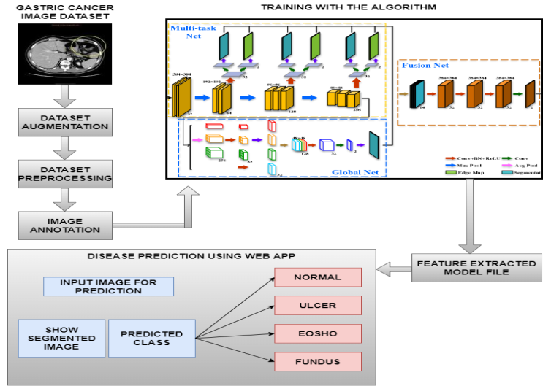

Fig. 1. System Architecture

MIFNET is an augmentation of three unique algorithms, collectively called as multi task net, fusion net and global net. The augmentation of these algorithms gives precise forecast of stomach cancer with no additional determination.

The System Architecture consists of the following modules.

* Gastric cancer Dataset Collection
* Dataset Pre-processing
* Annotating Images
* MIFNET Algorithm training
* Validation and Evaluation
* Cancer Prediction
* Web application development

## Gastric cancer Dataset Collection

In this proposed work, the gathered dataset will be utilized for preparing with the deep learning algorithms. Deep learning has turned into the go-to strategy for tackling many testing certifiable issues. A deep organization can recognize the central issues of each individuals in the picture. In this project, dataset is collected from hospital. The dataset contains images of cancer present in fundus, esophagus and ulcer present in the stomach. It also contains images without the presence of cancer. Totally we've collected 200 images for this project. Then the dataset is divided into two parts. Training dataset – 75% used to train an algorithm to understand and learn. Testing dataset – 25% used to evaluate how well an algorithm was trained.

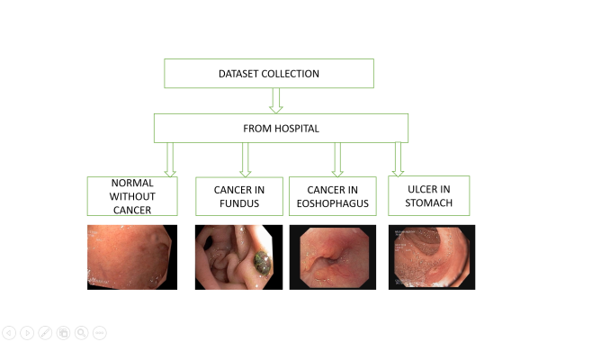

Fig. 2. Dataset Collection

## Dataset Pre-processing

Pre-Planning of an image done as to such an extent that the eliminated pictures does not have any contaminations and it is refined to be better for the forth coming process like division, include extraction and so on. Presence of noise in a picture gives grainy, snowy or textured appearance. Picture upgrade is done for increasing the contrast.

A real-world data we have collected from hospital cannot be directly used for deep learning models since it contains generally contains noises, missing values. The most well-known image information input boundaries are the number of images, height of the image, width of the image, number of channels, and the quantity of levels per pixel. All the images in the dataset are converted into same size with dimensions of 128*128*3. Hence the endoscopic images are resized using the convolutional layer. Aspect aware ratio is done for all the images in which the edges of the images are cut to make the images in the understandable format.

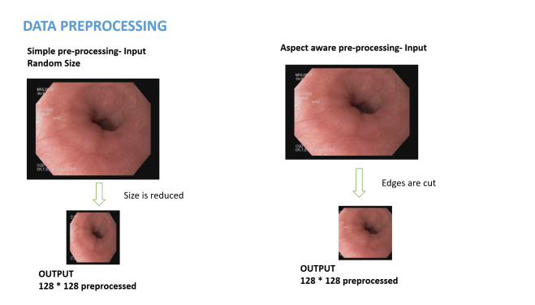

Fig. 3. Data Preprocessing

## Annotating Images

In this project, Annotation tool is used as an IDE. An annotation tool is a text or drawing apparatus that assists you with adding data to message, a picture, an information base, or some other piece of content. Picture comment is a kind of information naming that is some of the time called labeling, translating, or handling.

Picture explanation denotes the features and artificial intelligence framework to perceive, and utilizes the pictures to prepare the model utilizing administered learning. When the proposed model is conveyed, it is believed that the option to distinguish those features in pictures that poor person been explained and, thus, go with a choice or make some move. Picture explanation is most ordinarily used to perceive articles and limits and to section pictures for example, significance, or entire picture getting it. For every one of these purposes, it takes a lot of information to prepare, approve, and test an artificial intelligence model to accomplish the ideal result. The datasets are annotated using makesense.ai. After selecting the images from the dataset, object detection is selected. Label is created for each image. Region of Interest(ROI) is marked (i.e.), the part in which cancer is present is segmented. Finally, segmented data is produced as JSON file which is then given as the output for training.

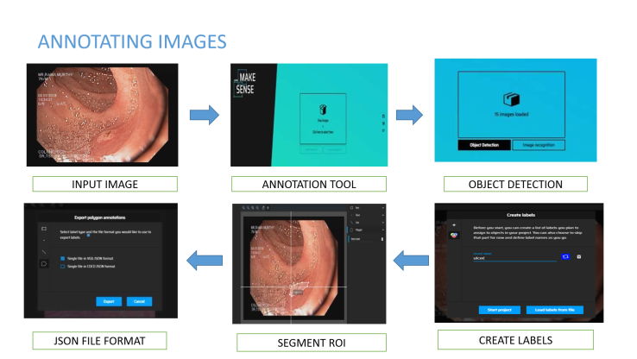

Fig. 4. Annotating Images

## MIFNET Algorithm training

First it enters into multi task net which helps to learn the dataset and covert all the images into same size using the layers present in that. Secondly it passes through global net to drive network efficiency and optimization at scale. Finally, it enters into fusion net which combines segmentation and classification part to produce an output file.



Fig. 5. MIFNET Algorithm Training

## Validation and Evaluation

Subsequent to applying the MIFNET calculations, the dataset has been separated into two sections: one for preparing and other for testing. 75% of the dataset goes to the preparation set and 25% to the testing set. In the wake of preparing information, the prepared model document has been created and the testing information is given to the prepared model record. Then, the component has been removed as a model record when an information picture is given for the illness expectation interaction and it will foresee the presence of sickness. Assuming the sickness is presents yes or no, the result will be contrasted and genuine information. Assuming that the information is valid, it will be exact and assuming that the information is misleading, it will be not precise. Finally, it will decide the presence of illness with higher exactness.

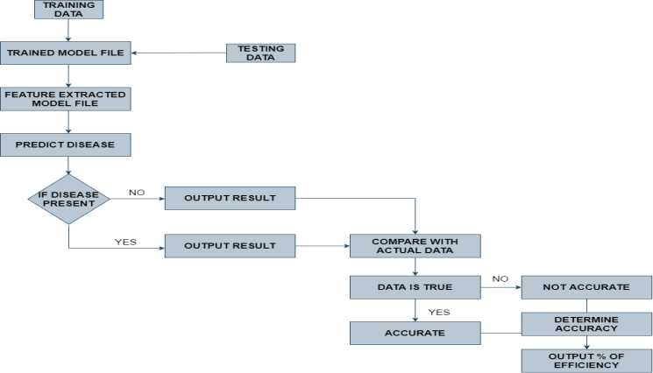

Fig. 6. Validation and Evaluation

## Cancer Prediction

The principle objective is to anticipate the forecast productivity that would be advantageous for the patients who are experiencing cancer in parts of the stomach and the rate proportion will be diminished. By and large in the primary phase of the sickness can be restored by the appropriate therapy. So distinguishing the infection at the beginning phase to improve the patients is significant. The fundamental reason for this exploration work is to observe the best expectation model for example the best Deep Learning method which will recognize the presence of ulcer or cancer in various parts of the patient stomach. After the approval and assessment, the last prepared model document has been created. At the point when an information picture is given, it will anticipate the infection and check regardless of whether the information is precise. Thus, we can undoubtedly anticipate the presence of infection with higher precision.

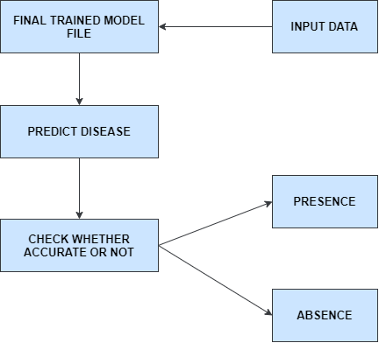

Fig. 7 . Cancer Prediction

## Web application development

React.js which is a java script library for developing user interface. Single-page applications can be built using React. Reusable UI components can be created using react. A web Application is created using React.js which is a java script library for developing user interface. Login page is created in which username, password and URL field is mentioned. The user has to give the username, password and the URL obtained in the backend coding developed in python. After that a page is directed where we can choose the image from your system which has to be predicted. Then a submit button should be clicked after which it displays the output.

# RESULT AND DISCUSSION

In any case, testing of the prepared model, the proposed work is divided into modules of execution that is finished. Dataset assortment includes the method involved with gathering dataset with presence and absence of cancer in various parts of the stomach.

The below table shows the classification report of model.

1. CLASSIFICATION REPORT OF THE MODEL

|  | Performance Analysis | | | |
| --- | --- | --- | --- | --- |
| Precision | Recall | F1-Score | Support |
| Esophagus | 0.94 | 1.00 | 0.97 | 16 |
| Fundus | 1.00 | 0.91 | 0.95 | 11 |
| Normal | 1.00 | 1.00 | 1.00 | 12 |
| Ulcer | 1.00 | 1.00 | 1.00 | 11 |
| Accuracy |  |  | 0.98 | 50 |
| Macro Average | 0.99 | 0.98 | 0.98 | 50 |
| Weighted Average | 0.98 | 0.98 | 0.98 | 50 |

The below table specifies the dataset collected from the hospital which are divided into four categories and the number of images used for testing and training.

1. DATASET COLLECTION

|  | Dataset Collection | | |
| --- | --- | --- | --- |
| No. of Images | Training | Testing |
| Esophagus | 50 | 37 | 13 |
| Fundus | 50 | 37 | 13 |
| Normal | 50 | 37 | 13 |
| Ulcer | 50 | 37 | 13 |

The below figure shows how the images are converted into same size by aspect aware pre-processing

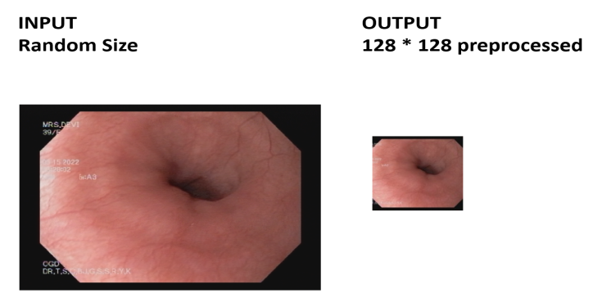

Fig. 8. Aspect aware Pre-Processing

Then these datasets are annotated using makesense.ai. The below figure shows that creating project in makesense.ai



Fig. 9. Creating project in makesense.ai

After selecting the images from the dataset, select object detection. The below figure shows the selecting object detection mode for annotating.



Fig. 10. Selecting object detection

After that, it will ask to create label. The below figure shows the assigning of class names in makesense.ai.

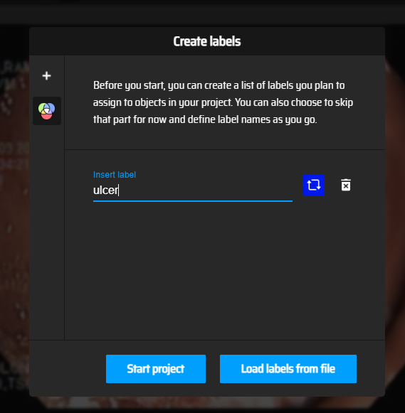

Fig. 11. Assigning Class Names

Then the images are annotated manually, for all the images in the dataset. The below figure shows the annotation of images.

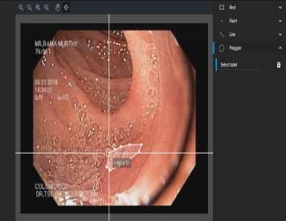

Fig. 12. Annotating Images

The below figure shows annotated images in json file format



Fig. 13. Exporting json format file

After exporting the json file, using this annotated data, binary mask images are created. The below figure shows the creation of binary masks for normal images.



Fig. 14. Creating binary masks for normal images

The below figure shows the creation of binary masks for eosho images.

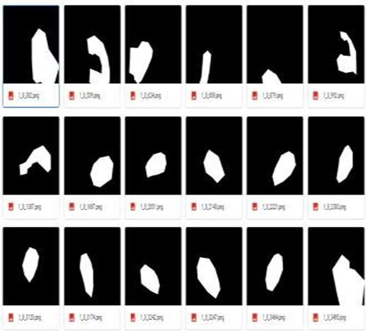

Fig. 15. Creating binary masks for eoshophagus images

The below figure shows the creation of binary masks for fundus images.

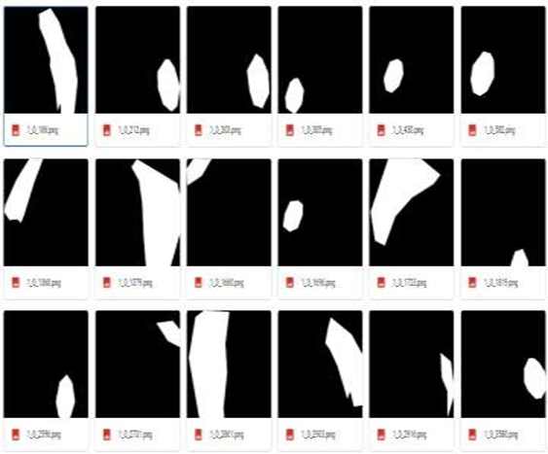

Fig. 16. Creating binary masks for fundus images

The below figure shows the creation of binary masks for ulcer images.

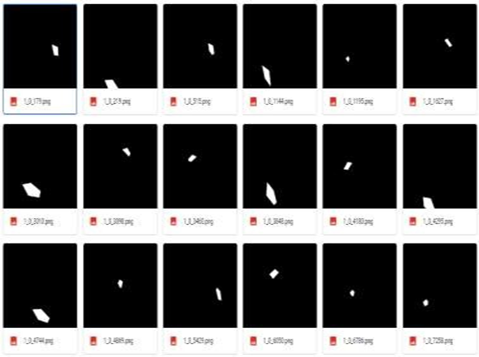

Fig. 17. Creating binary masks for ulcer images

The below figure shows the generation of trained model.

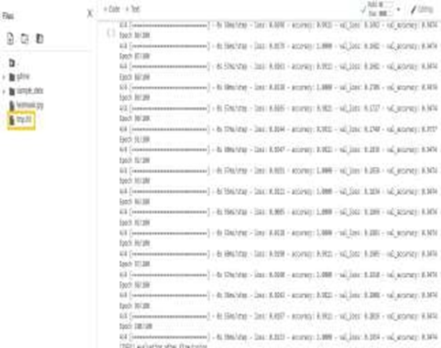

Fig. 17. Generation of trained model

# CONCLUSION

The proposed work has been effectively carried out to foresee the presence of the illness and decide if the individual has impacted from any infection and give earlier measures to keep away from the sickness. Dataset for various infection has been utilized and the various kinds of pre-handling strategies, picture explanations are performed. The MIFNET algorithm has helped to achieve an accuracy of 98% which is higher than the existing model. In clinical field they have more opportunity to create or change over this task in numerous ways. Subsequently, this proposed work has an effective degree in coming future where manual foreseeing can be changed over completely to electronic creation in a modest manner.

##### References

1. Ai-Min Yang,Yang Han*, Chen-Shuai Liu, Jian-Hui Wu, Dian-Bo Hua, ““D-TSVR Recurrence Prediction Driven by Medical Big Data in Cancer”, EEE Transactions on Industrial Informatics [Vol no: 17, 2020]
2. Bo Fu; Pei Liu; Jie Lin; Ling Deng; Kejia Hu; Hong Zheng, “Predicting Invasive Cancer-Free Survival for Early Stage Breast Cancer Patients Using Follow-Up Clinical Data”, IEEE Transactions on Biomedical Engineering [Vol no: 66, 2019]
3. Chih-Hung Chan; Tze-Ta Huang; Chih-Yang Chen; Chien-Cheng Lee; Man-Yee Chan; Pau-Choo Chung, “Texture-Map-Based Branch- Collaborative Network for Oral Cancer Detection”, IEEE Transactions on Biomedical Circuits and Systems [Vol no: 13, 2019]
4. Efthymios P. Papageorgiou; Bernhard E. Boser; Mekhail Anwar, “Chip- Scale Angle-Selective Imager for In Vivo Microscopic Cancer Detection”, IEEE Transactions on Biomedical Circuits and Systems [Vol no: 14, 2020]
5. Jean-SébastienBoisvert; Julie Lafontaine; Audrey Glory; Sylvain Coulombe; Philip Wong, “Comparison of Three Radio-Frequency Discharge Modes on the Treatment of Breast Cancer Cells in Vitro”, IEEE Transactions on Radiation and Plasma Medical Sciences [Vol no: 4, 2020]
6. Man-Sun Kim; Dongsan Kim; Jeong-Rae Kim, “Stage-Dependent Gene Expression Profiling in Colorectal Cancer”, IEEE/ACM Transactions on Computational Biology and Bioinformatics [Vol no: 16, 2019]
7. SeongRyeol Moon; Curt Balch; Sungjin Park; Jinhyuk Lee; Jiyong Sung; Seungyoon Nam, “Systematic Inspection of the Clinical Relevance of TP53 Missense Mutations in Gastric Cancer”, IEEE/ACM Transactions on Computational Biology and Bioinformatics [Vol no: 16, 2019]
8. Seungwoo Song, Student Member, IEEE, Jukwan Na, MoonHyung Jang, Student Member, IEEE, Hyeyeon Lee, Student Member, IEEE, Hye-Soo Lee, Yong-Beom Lim, Heonjin Choi, and YoungcheolChae, Senior Member, IEEE, “A CMOS VEGF Sensor for Cancer Diagnosis Using a Peptide Aptamer-Based Functionalized Microneedle”, IEEE Transactions on Biomedical Circuits and Systems [Vol no: 13, 2019]
9. ShaolongShi , Student Member, IEEE, Yifan Chen , Senior Member, IEEE, and Xin Yao, Fellow, IEEE, “NGA-Inspired Nanorobots-Assisted Detection of Multifocal Cancer”, IEEE Transactions on Cybernetics
10. Shuai Ding; Shikang Hu; Xiaojian Li; Youtao Zhang; Desheng Dash Wu, “Leveraging Multimodal Semantic Fusion for Gastric Cancer Screening via Hierarchical Attention Mechanism”, IEEE Transactions on Systems, Man, and Cybernetics: Systems
11. Uttam M. Pal; Anil Vishnu GK; GayatriGogoi; Saeed Rila; Saahil Shroff; Gokul AM; Pronami Borah; Manoj Varma, “Towards a Portable Platform Integrated With Multispectral Noncontact Probes for Delineating Normal and Breast Cancer Tissue Based on Near-Infrared Spectroscopy”, IEEE Transactions on Biomedical Circuits and Systems [Vol no: 14, 2020]
12. Xi Wang; Hao Chen; CaixiaGan; Huangjing Lin; Qi Dou; EfstratiosTsougenis; Qitao Huang; MuyanCai, “Weakly Supervised Deep Learning for Whole Slide Lung Cancer Image Analysis”, IEEE Transactions on Cybernetics [Vol no: 50, 2020]
13. Xiwei Tang; Qiu Xiao; Kai Yu, “Breast Cancer Candidate Gene Detection Through Integration of Subcellular Localization Data With Protein–Protein Interaction Networks”, IEEE Transactions on NanoBioscience [Vol no: 19, 2020]
14. Yi Wang; Na Wang; Min Xu; Junxiong Yu; Chenchen Qin; Xiao Luo; Xin Yang; Tianfu Wang; Anhua Li; Dong Ni, “Deeply-Supervised Networks With Threshold Loss for Cancer Detection in Automated Breast Ultrasound”, IEEE Transactions on Medical Imaging [Vol no: 39, 2020]
15. Yujie Feng; Fan Yang; Xichuan Zhou; YanliGuo; Fang Tang; Fengbo Ren; JishunGuo; Shuiwang Ji, “A Deep Learning Approach for Targeted Contrast-Enhanced Ultrasound Based Prostate Cancer Detection”, IEEE/ACM Transactions on Computational Biology and Bioinformatics [Vol no: 16, 2019]